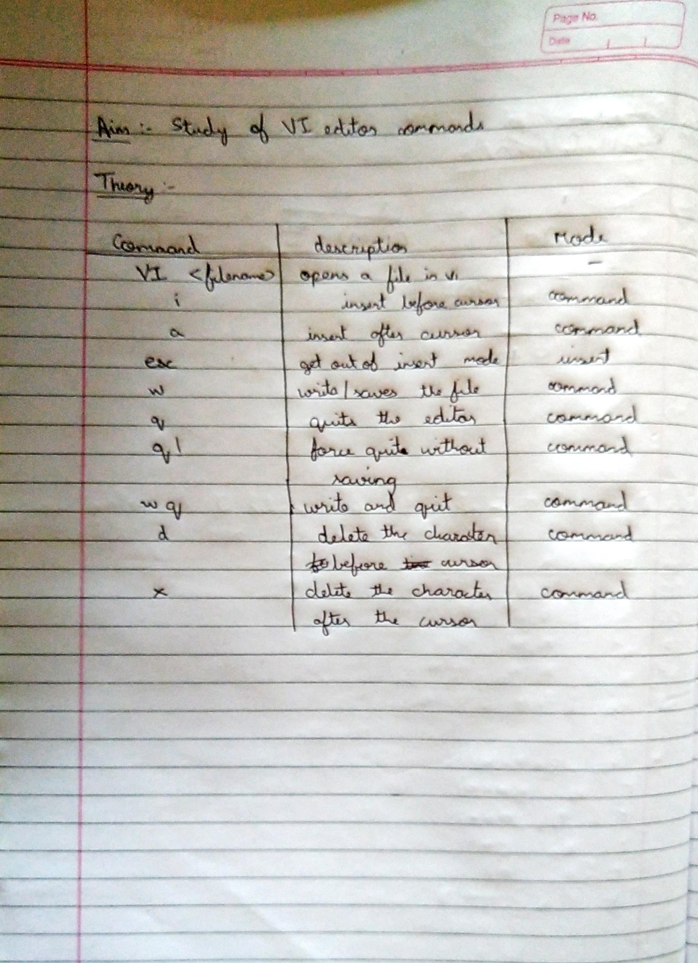

Vi Editor Output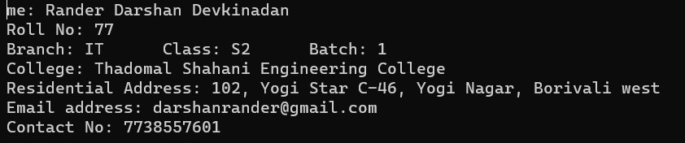

Cat Output

